System Security: Lab Manual

MS Cyber Security

ITU Lahore



Submitted to: Muhammad Shehryar Raza

Submitted By: Eisha Nawaz

Roll No: MSCS22007

Lab 6: Container Isolation, Misconfiguration & Least Privilege
Duration: 2 Hours
Mode: Group-based (Host / Container roles)
Tools:
- Docker
- Linux host
- Standard utilities (mount, ls)

1. Learning Objectives
Students will:
- Understand container isolation boundaries
- Exploit excessive privileges
- Apply least privilege to containers
- Recognize container escape risks

2. Scenario Description
A container is deployed with:
- --privileged mode
- Host filesystem mounted
- Root user inside container

3. Group Roles
- Attacker (Container): Exploits privileges
- Defender (Host): Hardens configuration

4. Environment Setup (15 minutes)
Run vulnerable container:
docker run --rm -it --privileged -v /:/host ubuntu bash

5. Step-by-Step Tasks

Task 1: Identify Excessive Privileges (15 minutes)
Inside container:
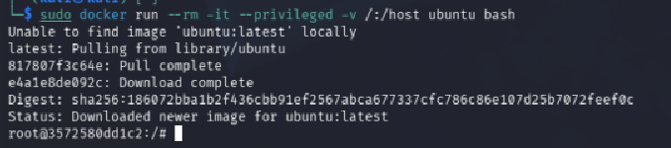
Id
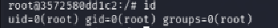
capsh --print
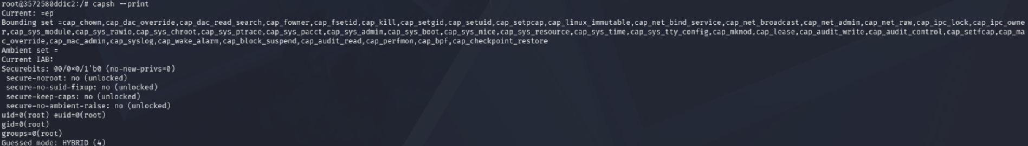
Observe:
- Full capabilities
The container has a complete set of Linux capabilities including dangerous ones like cap_sys_admin, cap_sys_ptrace, cap_net_admin, cap_sys_module etc. These are the same capabilities the host root user has the container is essentially unrestricted.

- Root privileges
I am running as uid=0(root) inside the container. This means I have full root access with no restrictions.

Task 2: Host Filesystem Access (20 minutes)
List host files:
ls /host/etc
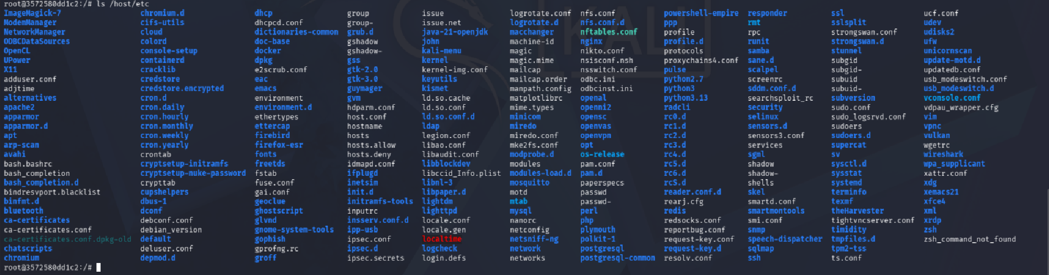

I can see all configuration files of the actual Kali host machine from inside the container. This proves the host filesystem is fully exposed there is no isolation.

cat /host/etc/shadow
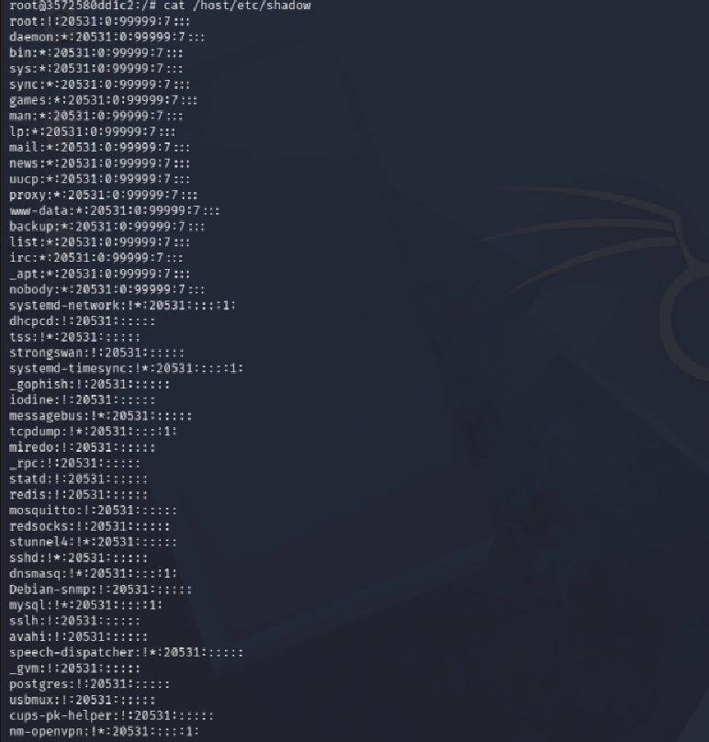
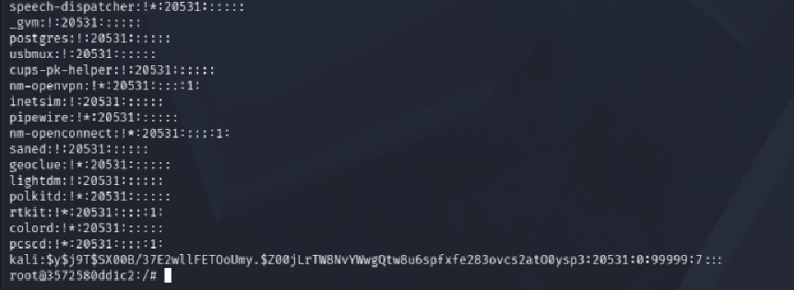
Discuss impact.
The shadow file is visible and readable. It contains hashed passwords of all user accounts on the Kali host machine. An attacker could copy these hashes and crack them offline using tools like hashcat or john the ripper, potentially gaining access to real user accounts.

Task 3: Privilege Abuse (15 minutes)
Mount host disk:
mount | grep host
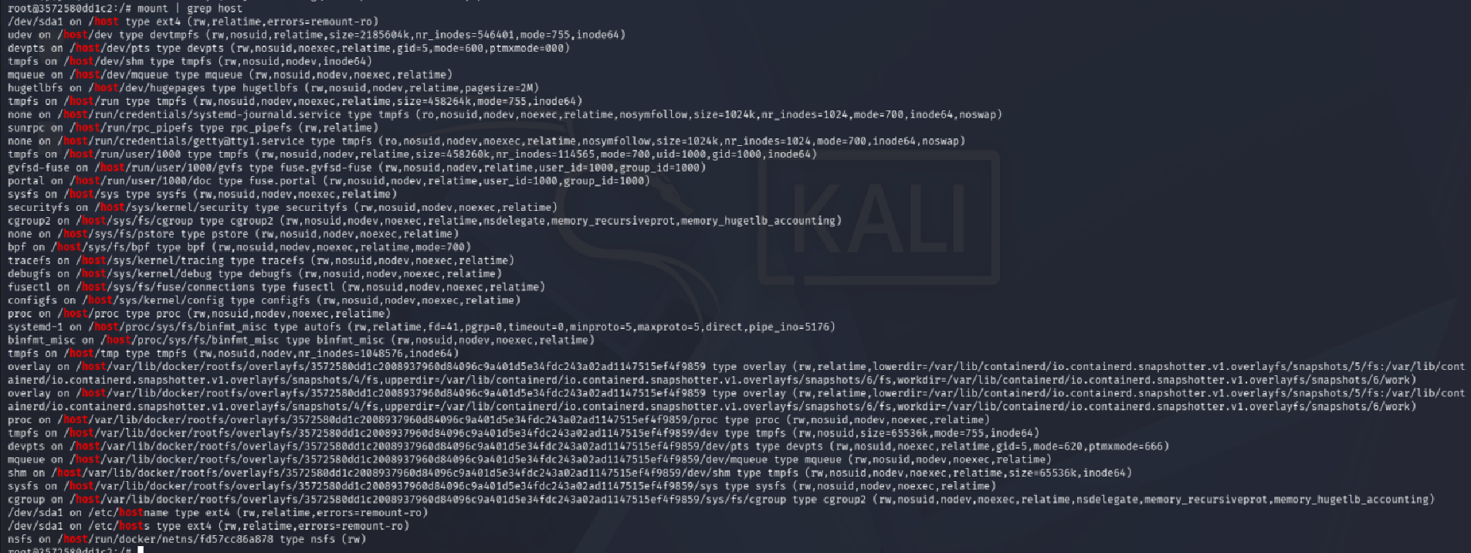
Explain how this breaks isolation.
The entire host root filesystem (/) is mounted inside the container at /host. This completely breaks container isolation the container can read, modify, or delete any file on the host.
All host directories are visible including /root, /home, /var, /etc. A real attacker could plant backdoors, modify system files, or steal credentials from any of these directories.

Task 4: Apply Least Privilege (20 minutes)
Stop container.
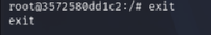
Re-run securely:
docker run --rm -it --cap-drop=ALL ubuntu bash
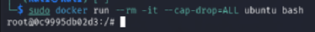

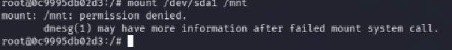
Command fails with "permission denied". The container can no longer interact with host disks confirming that dropping capabilities works.
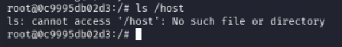
Fails with "No such file or directory". The host filesystem is completely inaccessible because we no longer mounted it with -v /:/host. The container is now properly isolated.
Verify:
- No mount access
- Reduced capabilities

Task 5: Security Reflection (20 minutes)
Answer:
- Why containers are not VMs
During this lab I ran an Ubuntu container on my Kali Linux host. Even though they are different operating systems, the container was sharing the same kernel as my Kali machine. This is the core difference:
- VMs have their own separate kernel, their own memory, and run on virtualized hardware. Even if a VM is compromised, the host is safe because there is a hypervisor layer in between.
- Containers are just isolated processes on the host kernel using Linux namespaces and cgroups. There is no separate kernel, no hardware virtualization just process-level separation.
This is why I was able to read /host/etc/shadow from inside the container it was my actual Kali machine's file. In a real VM, that would be completely impossible. Containers trade strong isolation for speed and lightweight performance, which makes misconfiguration extremely dangerous.
- Why --privileged is dangerous
When I launched the container with --privileged, the capsh --print output showed every single Linux capability was enabled. This means:

- The container could mount and unmount filesystems
- It could load and unload kernel modules
- It could modify network interfaces
- It could read any file on the host including /etc/shadow
- It could potentially overwrite host system binaries

Normally Docker drops most capabilities by default to limit what a container can do. The --privileged flag completely disables all of those protections. It is essentially handing the container the same power as the host's root user. If any application running inside a --privileged container gets exploited by an attacker, they immediately have full control over the host machine not just the container. This is why --privileged should never be used in production unless absolutely necessary, and even then only with extreme caution.
- Real-world container escape incidents
1. CVE-2019-5736 (runc Overwrite Attack)
This was one of the most serious container escape vulnerabilities discovered. An attacker with code execution inside a container could overwrite the host's runc binary (the tool Docker uses to start containers). The next time any container was started on that host, the attacker's malicious code would execute with full root privileges on the host machine. This affected Docker, Kubernetes, and any platform using runc. It was directly related to what we did in this lab a privileged container process touching host-level binaries.
2. CVE-2022-0492 (cgroup Namespace Escape)
A bug in the Linux kernel's cgroup v1 handling allowed a process inside an unprivileged container to abuse the release_agent feature to execute code on the host. This was dangerous because it did not even require –privileged, a normally configured container could be exploited if the host kernel was unpatched. It showed that even without explicit misconfigurations, kernel-level bugs can destroy container isolation.
3. Tesla Kubernetes Cryptojacking (2018)
Attackers discovered that Tesla's Kubernetes management dashboard was publicly exposed on the internet with no authentication. They logged in, found AWS cloud credentials stored in the environment, and deployed privileged containers across Tesla's infrastructure. These containers were used to mine cryptocurrency silently in the background. The attack went undetected for a period because the miners were throttled to avoid triggering performance alerts. This is a perfect real-world example of how container misconfiguration combined with excessive privileges leads to full infrastructure compromise.

6. Deliverables
- Screenshots of host access
- Secure vs insecure Docker commands
- 1-page reflection

